Attributions  
<https://opengameart.org/>

Tutorials  
Explanation <https://codehs.com/tutorial/andy/Programming_Sprites_in_JavaScript>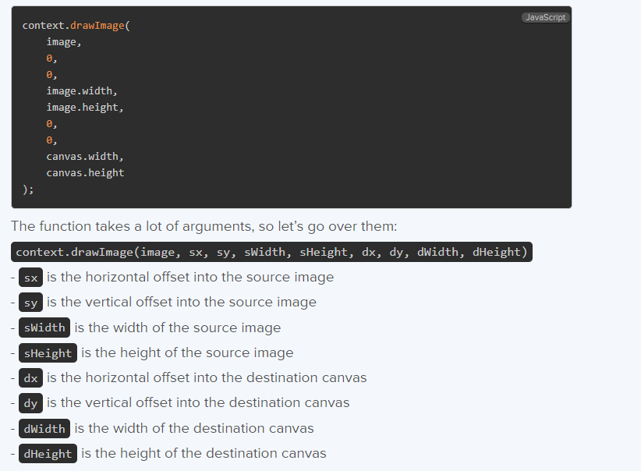

<https://opengameart.org/users/cynicmusic>

<https://opengameart.org/content/16x16-rpg-items>

The party attributions start  
<https://opengameart.org/content/antifareas-rpg-sprite-set-1-enlarged-w-transparent-background-fixed>

<https://www.deviantart.com/antifarea>

<https://opengameart.org/><https://creativecommons.org/licenses/by/3.0/>

End

<https://cypor.itch.io/12x12-rpg-tileset>

<https://master-blazter.itch.io/ghostspritepack> ghost enemy

Combat UI  
Credit to Chris Courses on YouTube <https://www.youtube.com/@ChrisCourses>Timestamp [Pokémon JavaScript Game Tutorial with HTML Canvas](https://youtu.be/yP5DKzriqXA?t=21365)The battle ui and the use of div to create overlays was taken the video also at the same timestamp  
The tile set used was also taken from the video it is linked above and can be found here as well  
<https://cypor.itch.io/12x12-rpg-tileset>

[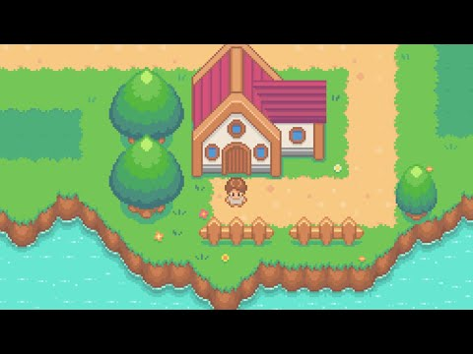](https://youtu.be/yP5DKzriqXA?t=21365)